Deleting a Database using cURL Utility

You can delete a database in CouchDB by sending a request to the server using DELETE method through cURL utility. Following is the syntax to create a database −

$ curl -X DELETE http://127.0.0.1:5984/**database name**

Using **−X** we can specify a custom request method of HTTP we are using, while communicating with the HTTP server. In this case, we are using the DELETE method. Send the url to the server by specifying the database to be deleted in it.

Example

Assume there is a database named my_database2 in CouchDB. Using the above given syntax if you want to delete it, you can do it as follows −

$ curl -X DELETE http://127.0.0.1:5984/my_database2

{

"ok" : true

}

As a response, the server will return you a JSON document with content **“ok”** − **true** indicating the operation was successful.

Verification

Verify whether the database is deleted by listing out all the databases as shown below. Here you can observe the name of the deleted database, **"my_database"** is not there in the list.

$ curl -X GET http://127.0.0.1:5984/_all_dbs

[ "_replicator " , " _users " ]

Deleting a Database using Futon

To delete a database, open the **http://127.0.0.1:5984/_utils/** url where you will get an Overview/index page of CouchDB as shown below.

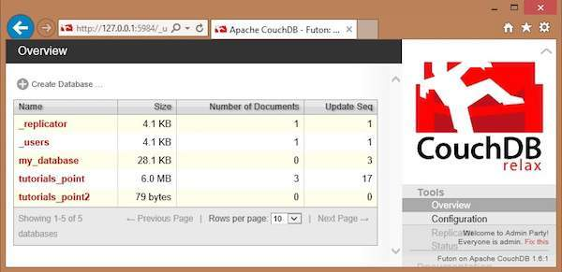

Here you can see three user created databases. Let us delete the database named tutorials_point2. To delete a database, select one from the list of databases, and click on it, which will lead to the overview page of the selected database where you can see the various operations on databases. The following screenshot shows the same −

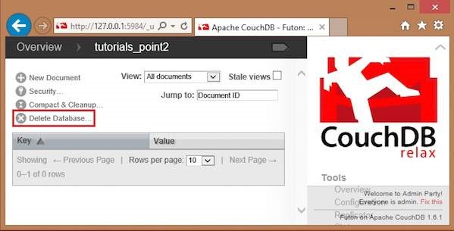

Among them you can find **Delete Database** option. By clicking on it you will get a popup window, asking whether you are sure! Click on delete, to delete the selected database.

